**ASSIGNMENT 1 (9/8/25)**

**1) Create the following dir structure**

**/**

**|**

**name**

**|**

**------------------------------------------------------**

**| | | |**

**company empid favourite sport dept**

**|**

**file1**

**(Welcome to Dept of works)**

file1 is a file

rest all are directories

**Answer:**

**Steps:**

1)ls – to show the list of files and directories

2)mkdir name – to create a directory with name as its name

3) cd name – Now change the directory to name

4) now use mkdir to create all the directories

5) cd company- Now change to the company directory

6) touch file1 -To create the file

7) cat > file 1 =>Welcome to dept work – To write the content in file1

8) cat file1 – to view the content in file1

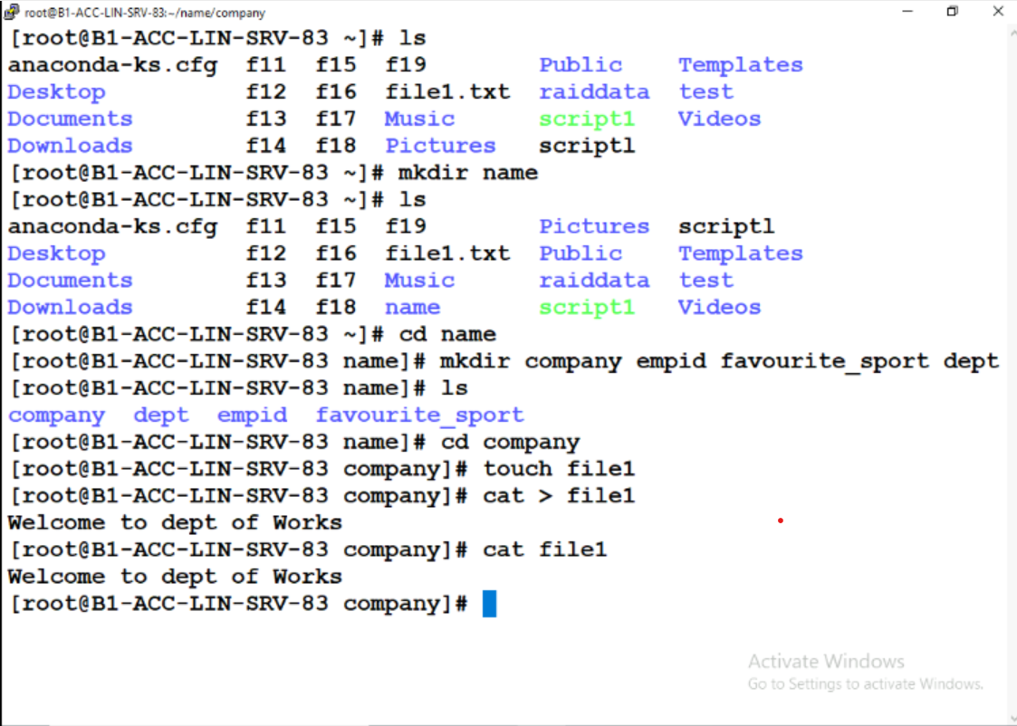

**2) Create the following dir structure**

**/**

**|**

**name (owner root, group prod rwx,r-x,r-x)**

**|**

**------------------------------------------------------**

**| | | |**

**company empid favourite sport dept (owner root, group prod rwx,rw-,r--)**

**|**

**file1( owner student, group sales rw-,r--,r--)**

**(Welcome to Dept of works)**

**Note: file1 is a file**

**rest all are directories**

